P5思考题解答

流水线冲突解决了前流水级需要的数值是还没有来得及写入的数值。本设计考虑匹配寄存器的方式解决转发，只要满足以下条件：

1. 已经产生了需要写入的数据
2. 转发的元寄存器非0
3. 寄存器写使能为1
4. 两两流水级之间使用和准备写入寄存器号匹配

即可转发。

由于流水线IF级不需要对寄存器的操作，故这里我们可能进行的转发路径共有六条；再仔细分析，1. 对于ID 🡪 EX，在ID级需要使用寄存器值的只有Branch和Jump指令，由于延迟槽的存在，两条B, J指令并不能连续出现，而在EX级可能产生新值的指令只有Link型指令，故不需要构建EX 🡪 ID的转发；2. 对于WB 🡪 MEM，可以通过GRF片内转发实现。

本设计中将W->M级写入数据汇总，方便转发

处理转发的代码如下：

reg [1:0] _ForwardRSD, _ForwardRTD, _ForwardRSE, _ForwardRTE, _ForwardRTM, _ForwardRTE_ALUb;

//reg [1:0] _ForwardRaF;

assign ForwardRSD = _ForwardRSD;

assign ForwardRTD = _ForwardRTD;

assign ForwardRSE = _ForwardRSE;

assign ForwardRTE = _ForwardRTE;

assign ForwardRTM = _ForwardRTM;

assign ForwardRTE_ALUb = _ForwardRTE_ALUb;

always @* begin

if (ReReg1_D == WrReg_M && RegWr_M && generated_M && ReReg1_D)

_ForwardRSD = `WrData_M;

else if (ReReg1_D == WrReg_W && RegWr_W && generated_W && ReReg1_D)

_ForwardRSD = `WrData_W;

else

_ForwardRSD = 2'b00;

if (ReReg2_D == WrReg_M && RegWr_M && generated_M && ReReg2_D)

_ForwardRTD = `WrData_M;

else if (ReReg2_D == WrReg_W && RegWr_W && generated_W && ReReg2_D)

_ForwardRTD = `WrData_W;

else

_ForwardRTD = 2'b00;

end

always @* begin

if (ReReg1_E == WrReg_M && RegWr_M && generated_M && ReReg1_E)

_ForwardRSE = `WrData_M;

else if (ReReg1_E == WrReg_W && RegWr_W && generated_W && ReReg1_E)

_ForwardRSE = `WrData_W;

else

_ForwardRSE = 2'b00;

if (ReReg2_E == WrReg_M && RegWr_M && generated_M && ReReg2_E)

_ForwardRTE = `WrData_M;

else if (ReReg2_E == WrReg_W && RegWr_W && generated_W && ReReg2_E)

_ForwardRTE = `WrData_W;

else

_ForwardRTE = 2'b00;

end

always @* begin

if (ReReg2_M == WrReg_W && RegWr_W && generated_W && ReReg2_M)

_ForwardRTM = `WrData_W;

else

_ForwardRTM = 2'b00;

end

当以上的转发路径中，若在需求寄存器的值的时候新值还没有产生，便无法直接用转发解决冲突，需要通过暂停处理。通过分析Tuse,Tnew在冲突控制单元中在指令进入ID级的时候判断是否暂停。

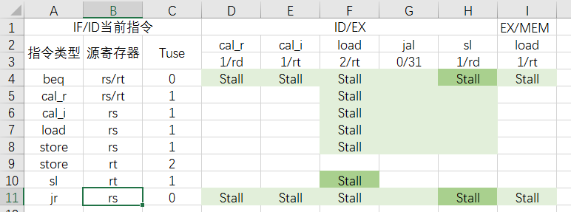

处理暂停的代码如下：

wire stall_b, stall_calr, stall_cali, stall_ld, stall_st, stall_jr, stall_sl, temp;

assign temp = (stall_b || stall_calr || stall_cali || stall_ld || stall_st || stall_jr || stall_sl);

assign stall = (temp === 1'bx)? 0:temp;

assign stall_b = beq_D && ((Cal_r_E && (IR_D[`rs] == IR_E[`rd]||IR_D[`rt] == IR_E[`rd]))

||(Cal_i_E && (IR_D[`rs] == IR_E[`rt]||IR_D[`rt] == IR_E[`rt]))

||(ld_E && (IR_D[`rs] == IR_E[`rt]||IR_D[`rt] == IR_E[`rt]))

||(sl_E && (IR_D[`rs] == IR_E[`rd]||IR_D[`rt] == IR_E[`rd]))

||(ld_M && (IR_D[`rs] == IR_M[`rt]||IR_D[`rt] == IR_M[`rt])));

assign stall_calr = Cal_r_D && ld_E && (IR_D[`rs] == IR_E[`rt]||IR_D[`rt] == IR_E[`rt]);

assign stall_cali = Cal_i_D && ld_E && (IR_D[`rs] == IR_E[`rt]||IR_D[`rt] == IR_E[`rt]);

assign stall_ld = ld_D && ld_E && IR_D[`rs] == IR_E[`rt];

assign stall_st = st_D && ld_E && IR_D[`rs] == IR_E[`rt];

assign stall_sl = sl_D && ld_E && IR_D[`rt] == IR_E[`rt];

assign stall_jr = jr_D && ((Cal_r_E && IR_D[`rs] == IR_E[`rd])

||(Cal_i_E && IR_D[`rs] == IR_E[`rt])

||(sl_E && IR_D[`rs] == IR_E[`rd])

||(ld_E && IR_D[`rs] == IR_E[`rt])

||(ld_M && IR_D[`rs] == IR_M[`rt]));